1.Question 8 and 9 is compulsory .pdf

Note:

1.Try inline CSS for styling.

2.Try select tag(try size attribute)

Example: <select>

<option>Apple</option>

<option>Banana</option>

<option>Pineapple</option>

</select>

3.Try textarea tag(try rows and cols attribute)

Example: <textarea></textarea>

1. Create a web page to show your name
2. Create a web page to show Student name in ordered list Output:

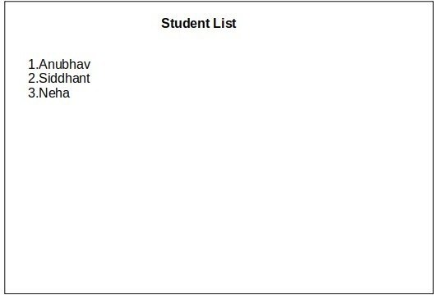

1. Create nested list of Students

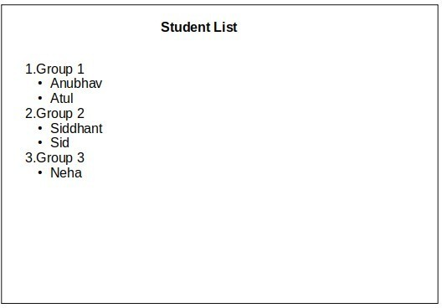

1. Create a nested list.

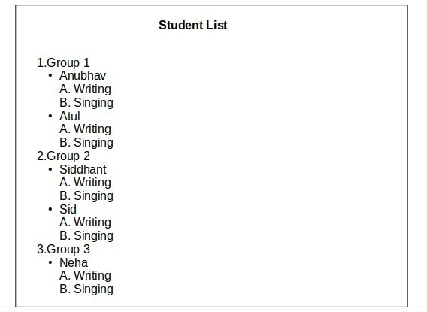

1. Create a web page resume.

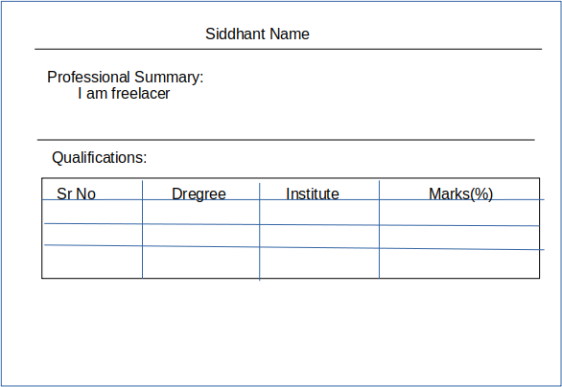

1. ​

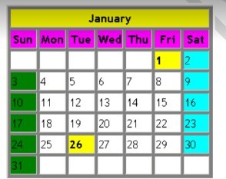

1. ​

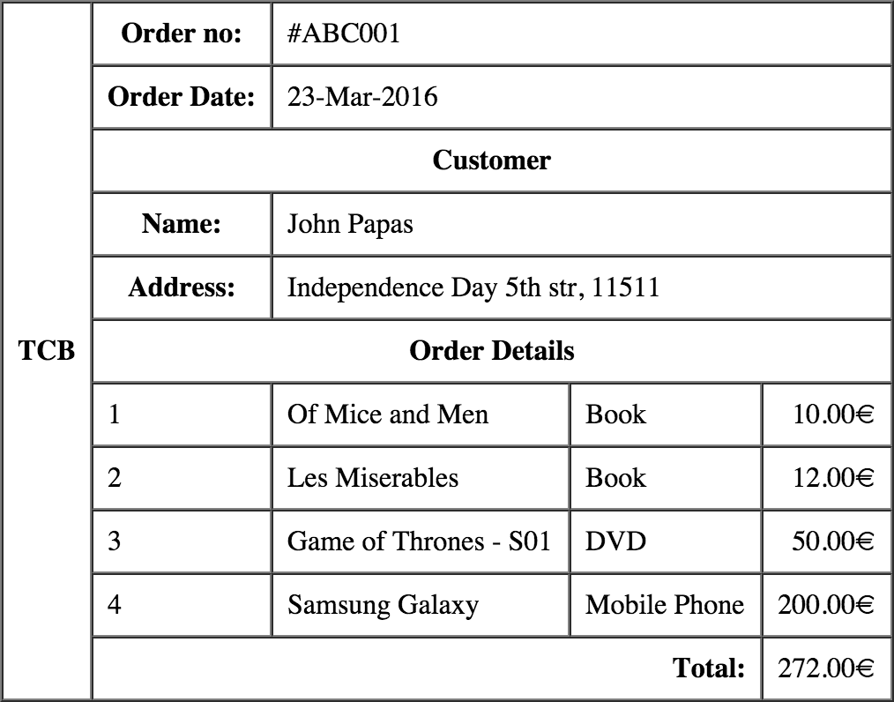

1. ​

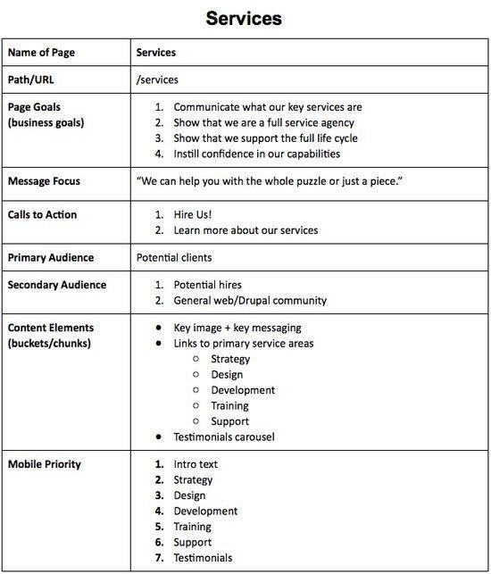

HTML assignments

9​

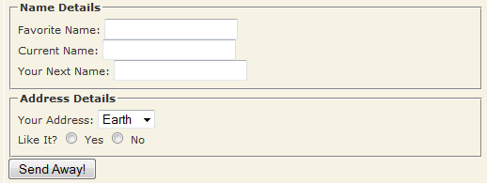

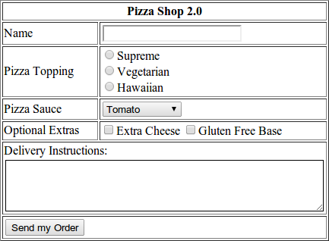10.​

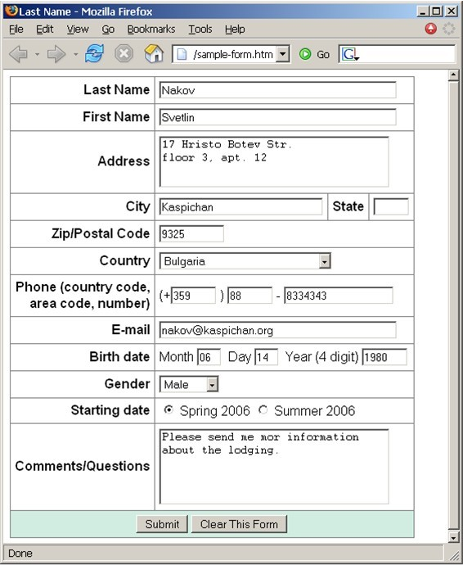11.​

12.Design given page and link Q1,Q2 and Q3 on page to question 1 ,2,3

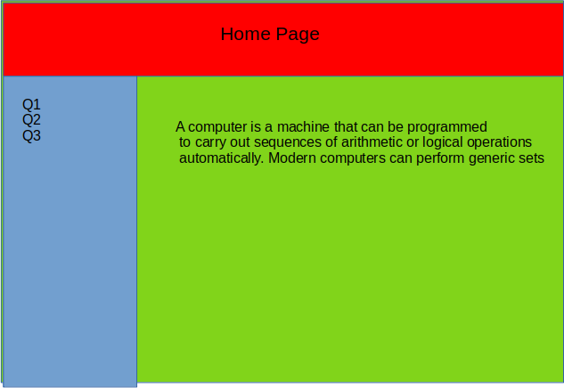

13.​

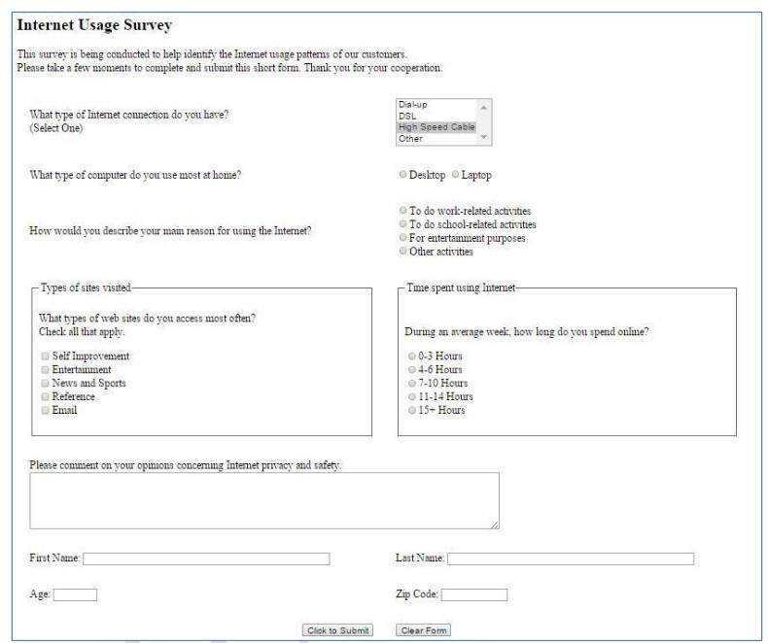

14.

